THEMENBLOCK 15: DIFFERENT CULTURES & TRADITIONS
CATEGORY A: CONTRASTING IMAGES
TASK SET A1: Urban Diversity vs. Rural Tradition
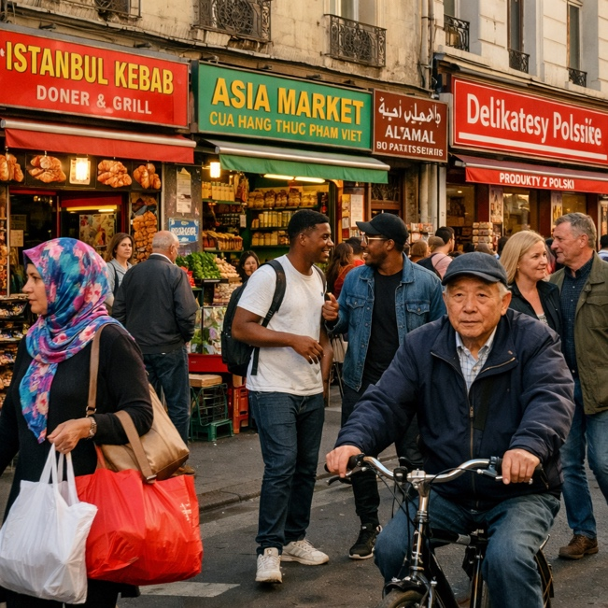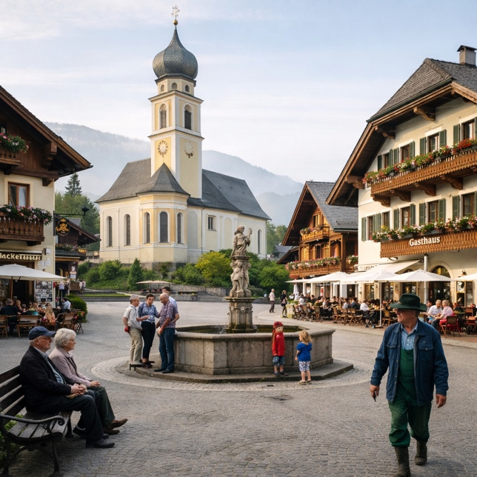
Task:
Give a five-minute talk on cultural diversity in urban and rural settings in which you
- Describe, compare and contrast the two pictures above.
- Analyze factors leading to cultural diversity in cities versus rural areas.
- Discuss the pros and cons of living in culturally diverse versus culturally uniform communities.
PART 2 — Paired Activity
Task:
Your school is creating a campaign called "Unity in Diversity" to promote intercultural understanding in your community. You and your partner need to decide on the campaign's focus. Discuss the ideas below and agree on THREE to include:
- Photo exhibition showing the multicultural history of your town or region
- "Cultural exchange" cooking events where families share traditional recipes
- Multilingual welcome signs for public spaces
- Buddy program pairing local students with newcomers
- Podcast series interviewing long-term residents and recent immigrants about their experiences

TASK SET A2: Traditional Ceremony vs. Multicultural Celebration
PART 1 — Individual Long Turn
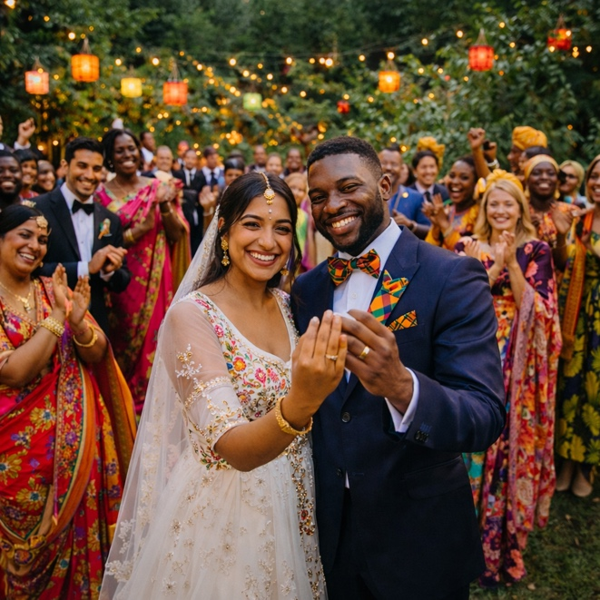
Task:
Give a five-minute talk on how cultural traditions evolve across generations in which you
- Describe, compare and contrast the two pictures above.
- Analyze why and how traditional ceremonies like weddings have changed in multicultural societies.
- Discuss whether blending cultural traditions strengthens or weakens cultural identity.
PART 2 — Paired Activity
Task:
Your class is preparing a presentation on "Traditions in Transition" for a cultural studies project. You need to decide which questions to explore. Discuss the following questions and agree on THREE to focus your research on:
- How do families negotiate when partners come from different cultural backgrounds?
- Should traditional ceremonies be preserved exactly as they were, or is adaptation natural and healthy?
- What role do younger generations play in changing or maintaining family traditions?
- How has globalization affected local customs and celebrations?
- Can new, blended traditions become as meaningful as centuries-old practices?

TASK SET A3: Preserving Culture — Museums vs. Living Practice
PART 1 — Individual Long Turn
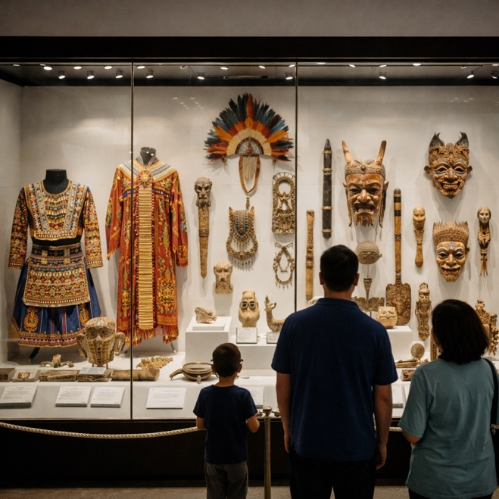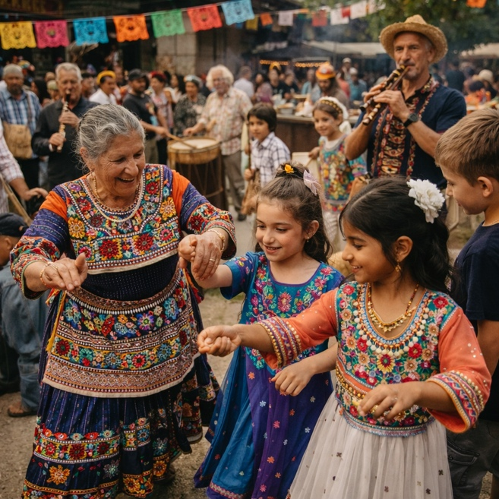
Task:
Give a five-minute talk on different approaches to preserving cultural heritage in which you
- Describe, compare and contrast the two pictures above.
- Evaluate the advantages and limitations of preserving culture in museums versus through living community practice.
- Discuss what is lost and what is gained when cultural artifacts are removed from their original context.
PART 2 — Paired Activity
Task:
Your town is organizing a "Living Heritage Festival" to celebrate the diverse cultural backgrounds of residents. You and your partner are on the planning committee. Discuss and agree on these organizational aspects:
- Venue and date: indoor vs. outdoor, seasonal considerations, accessibility
- Activities: demonstrations, workshops, performances, or exhibitions?
- Community involvement: how to recruit participants from different cultural groups
- Educational component: information displays, guided tours, or hands-on learning?
- Documentation: how to record and share the event for those who cannot attend

CATEGORY B: QUOTES
TASK SET B1: The Danger of a Single Story
PART 1 — Individual Long Turn
Quote Prompts:
"The single story creates stereotypes, and the problem with stereotypes is not that they are untrue, but that they are incomplete. They make one story become the only story."
— Chimamanda Ngozi Adichie, TED Talk: "The Danger of a Single Story" (TEDGlobal, July 2009)
"Difference is of the essence of humanity. Difference is an accident of birth and it should therefore never be the source of hatred or conflict. The answer to difference is to respect it."
— John Hume, Nobel Peace Prize Lecture (December 10, 1998)
Task:
Give a five-minute talk on stereotypes and cultural understanding in which you
- Analyze and compare the two quotes above, explaining what each speaker means.
- Discuss how 'single stories' about cultures develop and spread, and what harm they can cause.
- comment on personal experiences with cultural stereotypes.
PART 2 — Paired Activity
Task:
You have been invited to speak at a youth conference on "Media Representation and Cultural Stereotypes." Before your presentation, discuss the following topics with your partner and agree on THREE to focus on:
- How news media coverage creates or reinforces stereotypes about certain groups
- The responsibility of filmmakers and TV producers in representing diverse cultures
- Social media's role in both spreading and challenging cultural stereotypes
- How travel and personal contact can break down stereotypical thinking
- Educational approaches to developing critical media literacy

TASK SET B2: Melting Pot or Mosaic?
PART 1 — Individual Long Turn
Quote Prompts:
"We become not a melting pot but a beautiful mosaic. Different people, different beliefs, different yearnings, different hopes, different dreams."
— Jimmy Carter, Campaign speech in Pittsburgh, Pennsylvania (October 27, 1976)
"My humanity is bound up in yours, for we can only be human together."
— Desmond Tutu, Various speeches and writings on Ubuntu philosophy (Frequently cited from 1990s onwards)
Task:
Give a five-minute talk on models of cultural integration and coexistence in which you
- Analyze and compare the two quotes above.
- discuss 'melting pot' versus 'mosaic' approaches to cultural integration and their tradeoffs.
- Comment on which model you think works best for modern societies and why.
PART 2 — Paired Activity
Task:
You are student representatives consulting with a social integration specialist. Your school district is developing a new integration policy for students from immigrant backgrounds. Discuss these focus areas and agree on THREE priorities:
- Language support: intensive German courses vs. multilingual classroom approaches
- Cultural recognition: celebrating diverse holidays and traditions in school
- Social integration: structured buddy systems vs. organic friendship development
- Parent involvement: outreach to immigrant families, translation services, cultural mediators
- Teacher training: intercultural competence workshops for all staff

CATEGORY C: ALTERNATIVE PROMPTS
TASK SET C1: European Attitudes Toward Cultural Diversity
PART 1 — Individual Long Turn
Text Extract:
According to Special Eurobarometer 535 on "Discrimination in the EU" (2023), Europeans hold complex views on cultural diversity. While 86% of EU citizens believe everyone should speak at least one language in addition to their mother tongue, and 84% think regional and minority languages should be protected, attitudes toward diversity in daily life vary significantly. The survey found that 45% of respondents cite "understanding other cultures" as a key benefit of language learning. However, discrimination based on ethnic origin remains the most widely perceived form of discrimination in the EU, with rates varying considerably across member states. The report emphasizes that improving language skills should be a policy priority according to 76% of Europeans, suggesting a strong belief in communication as a bridge between cultures.
Task:
Give a five-minute talk on European attitudes toward cultural diversity in which you
- Explain what the statistics reveal about European attitudes toward language and cultural diversity.
- Analyze the contradiction between support for diversity and ethnic discrimination.
- Comment on whether language learning alone can bridge cultural divides.
PART 2 — Paired Activity
Task:
Your school is debating the motion: "Schools should prioritize teaching students about cultural diversity over teaching additional foreign languages." Take opposing positions and discuss these aspects before reaching a balanced conclusion:
- The relationship between language learning and cultural understanding
- Practical benefits of language skills vs. cultural awareness in the job market
- Whether cultural understanding can exist without language proficiency
- Time constraints in the curriculum: what should be prioritized?
- The role of schools vs. families in teaching cultural values
═══════════════════════════════════════════════════════════════

TASK SET C2: Building Bridges — Youth Exchange Programs
PART 1 — Individual Long Turn
Text Extract:
The European Union's Erasmus+ programme represents one of the world's largest investments in youth mobility and intercultural learning. The 2021-2027 programme targets 10 million Europeans for learning mobility opportunities. Youth exchanges specifically bring together young people aged 13-30 from at least two different countries for 5-21 days, focusing on intercultural dialogue, active citizenship, and solidarity. According to the European Youth Portal, over 670 transnational cultural cooperation projects were funded between 2021-2024. Research consistently shows that participants report increased intercultural competence, greater confidence in navigating unfamiliar situations, and stronger European identity. Former exchange participants are significantly more likely to consider working or studying abroad in the future and report feeling better equipped to collaborate with people from different backgrounds.
Task:
Give a five-minute talk on the value of international youth exchange programs in which you
- Explain what the statistics reveal about the scale and goals of European youth exchange programs.
- Discuss the reported benefits and limitations of intercultural exchange.
- Comment on whether you would participate and what you would gain.
PART 2 — Paired Activity
Task:
Your school has been offered funding to participate in a youth exchange program. You and your partner need to recommend the type of exchange. Discuss the options below and agree on TWO to propose:
- Two-week exchange with a partner school in another EU country (homestay with local families)
- One-week intensive intercultural workshop bringing students from five countries to your school
- Virtual exchange program with regular video calls and collaborative online projects over six months
- Volunteering project in another country focused on community service and cultural immersion
- Language immersion exchange with focus on improving foreign language skills

